Exploring the Synthesis and Energy Storage Applications of Graphene

Richard B. Kaner
Distinguished Professor of Chemistry
Distinguished Professor of Materials Science & Engineering
Dr. Myung Ki Hong Endowed Chair in Materials Innovation
Univerisity of California, Los Angeles

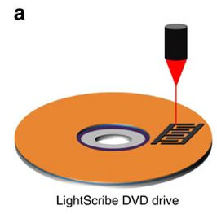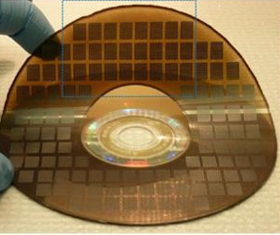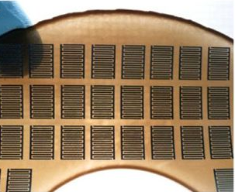Graphene is the ultimate two-dimensional material consisting of a single layer of sp² hybridized carbon. A facile, inexpensive, solid-state method for generating, patterning and electronic tuning of laser converted graphene will be discussed (Figure 1). Briefly, graphite can be converted into graphene oxide (GO) sheets, which readily disperse in water, and can then be reduced by various methods. Due to its unique ability to be solution processed and patterned, GO can be laser reduced to graphene directly onto various substrates without masks, templates, post processing, or transfer techniques. This work paves the way for the fabrication of inexpensive electrochemical energy storage devices that combine the energy density of batteries and the power density of capacitors.
b
c
a
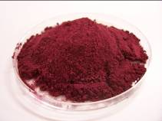
Figure 1 (a) Schematic showing the fabrication process of a graphene micro-supercapacitor using a Light Scribe DVD drive. (b,c) This technique can create more than 100 micro-devices in a single run on virtually any substrate.

References:
1. D. Li, M.B. Muller, S. Gilje, R.B. Kaner and G.G. Wallace, “Processable aqueous dispersions of graphene nanosheets”, Nature Nanotechnology 3, 101-105 (2008).
2. M.F. El-Kady, V. Strong, S. Dubin and R.B. Kaner, “Laser printing of flexible graphene-based supercapacitors with ultrahigh power and energy densities”, Science 335, 1326-1330 (2012).
3. J.Wassei, R.Kaner, “Oh the places you’ll go with graphene”, Acc. Chem. Res., 46, 2244-2251 (2013).
4. M.F. El-Kady, M. Ihns, M. Li, J.Y. Hwang, M.F. Mousavi, L. Chaney, A.T. Lech and R.B. Kaner, “Engineering three-dimensional hybrid supercapacitors and microsupercapacitors for high-performance integrated energy storage”, Proc. Nat. Acad. Sci., 112, 4233-4238 (2015).
5. M.F. El-Kady, Y. Shao, R.B. Kaner, “Graphene for batteries, supercapacitors and beyond”, Nature Review Materials, 1, 16033-16046 (2016).
6. Y. Shao, M.F. El-Kady, J. Sun, Y. Li, Q. Zhang, M. Zhu, H. Wang, B. Dunn and R.B. Kaner, “Design and mechanisms of asymmetric supercapacitors”, Chem. Rev., 118, 9233-9280 (2018).
7. N.B. Mohamed, M.F. El‐Kady and R.B. Kaner, “Macroporous graphene frameworks for sensing and supercapacitor applications,” Adv. Funct. Mater. 32, 2203101 (2022).

